1-(f)

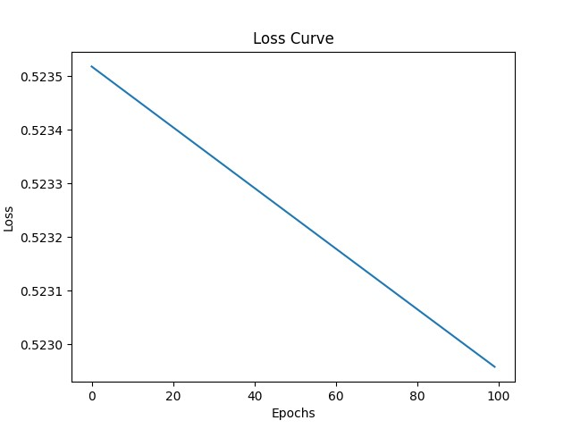

1-(g)

Confusion matrix for test dataset: [[53 2][ 0 45]]

From this it can be calculated that:

Accuracy = (45+53)/(53+2+0+45)=0.98

The model has 98% accuracy on the test set, which indicates that the model is generally able to predict the class of the sample well.

1-(h)

Train Accuracy: 0.99

Test Accuracy: 0.98

From these results, the training accuracy is higher than the testing accuracy, which is usually a sign of overfitting. However, the difference in accuracy is not large at 1%.

To further improve the generalization of the model, the following steps can be taken:

**L2 Regularization**: prevent the weight values from being too large by adding a weight penalty term to the loss function.

**Increase the amount of data**: more training data can help the model learn a wider range of features and reduce overfitting.

**Adjust the model structure**: The number of neurons or layers in the hidden layer can be appropriately reduced to prevent the model from being too complex.

1-(i)

